OreSat Deployable Antennas

Final Report

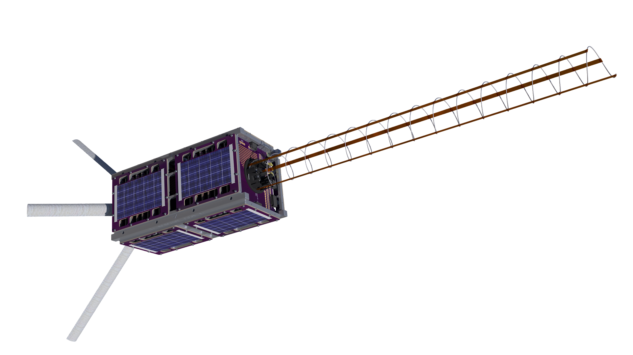Team Members

*Calvin Young*

*Shivani Nadarajah*

*John George*

*Paijanne Jones*

*Justin Burris*

Sponsors

*Andrew Greenberg*

*Glenn LeBrasseur*

ME 493

*Gerald Recktenwald*

*11 June 2018*

Table of Contents

**Team Members** **2**

**Executive Summary** **3**

Project Objective Statement 3

Final Status of Design Project 3

Key Performance Metrics 3

**Client and Market Requirements** **4**

OreSat Requirements 4

CubeSat Design Specifications 4

NASA Regulations 4

NanoRacks Constraints 4

**Conceptual Design Summary** **6**

Subsystem Highlights 10

Canted Turnstile Array 10

Bistable Spring Manufacturing 10

Deployment Structure 11

S Band Helical Antenna 12

Spring Manufacturing 12

Constraint Tethers 13

Deployment Mechanism 15

Burn Wire 15

Performance Summary 16

Final Status 17

**Appendices** **19**

Supplemental Images 19

Catalog of Design Artifacts 27

Concept Analysis 27

Bill of Materials 27

System-Level Requirements Matrix 28

# 

# Team Members

**Calvin Young** came into the capstone with previous experience working with the OreSat team on the satellite’s structure and reaction control system. With this perspective, he focused on integration of the capstone work with the larger scope of the overarching project’s team and its requirements. His coordination with external resources enabled the team dive into vibration testing and manufacturing of the helical antenna. Driving communication with the capstone’s sponsors and partners derived insight into technical challenges which helped guide decisions for the helical antenna.

**Shivani Nadarajah** dove deep into research and simulation while designing the S band antenna. She directed the team to settle on a uniform helical form factor which she showed to be capable of hitting the design targets for the gain and other RF parameters. Her experience as a researcher enabled the team to overcome these initial hurdles before moving to design the mechanical systems, for which her review of literature proved invaluable. She validated assumptions and provided calculations to ensure that the manufacture specifications of the helical antenna would produce a flight-ready solution for the satellite mission.

**John George** continuously iterated on prototypes for the deployment designs and helped push the team forward at a steady pace. His accelerated physical demonstrations revealed flaws in the subsystem which helped identify solutions for the specific application requirements that OreSat demands. He proved indispensable in designing and running various experiments throughout the course of the project, and is continuing to develop plans for ongoing tests.

**Paijanne Jones** developed early prototypes of the turnstile deployment mechanism which became instrumental in re-designing the subsystem in response to a change in the project requirements. Her prescience facilitated a quick transition that enabled the team to present a viable solution to the newly imposed restrictions. She was an essential part of every document and presentation that the capstone produced, and her dedication to the success of the project was evident in all of her work.

**Justin Burris** worked on early designs of the vibration test fixtures before focusing on the design and manufacturing of the deployment mechanism for the helical antenna. He focused the efforts to manufacture the helical antenna by hand before transitioning to a professional spring manufacturer. His CAD work enabled the team to maximize use of rapid prototyping tools. With his experience in mechanical design he facilitated approaches to many of the project’s hands-on technical challenges.

# Executive Summary

## Project Objective Statement

Design, test, and manufacture two communication antenna packages and their deployment systems for Oregon's first satellite (OreSat) with support from the Oregon Space Grant Consortium (OSGC).

## Final Status of Design Project

With the recent changes in requirements for the canted turnstile array, the team was not able to deliver a functional prototype using flight-ready materials. The new design necessitated the use of fiberglass as a structural component and the sourcing and manufacturing of this material has proved to be quite time-consuming, though a clear path forward has been defined based on successful implementation of similar designs by other academic groups. The deployment mechanism of this revised turnstile array has been validated and demonstrated using (the originally viable) metallic structural members.

The tethers used to constrain the deployed helical antenna needed to be compact and lightweight while minimizing the risk of entanglement during deployment. Strips of Kapton were chosen for the final design for their superior compliance, environmental resilience, and their minimal contribution to the stacked height of the spring. The system proved to be both stiff and quickly damping, mitigating any risk of untenable dynamics caused by the satellite’s reaction control system. The helical deployment mechanism was designed to accommodate the tethers and constrain the compressed antenna while stowed beneath a 15 mm ceiling. It was derived from a mechanism used on an Indian satellite described in an academic paper. Further work is needed to test and validate the design architecture with an eye for minimizing the risk of deployment failure modes.

Experiments (the results of which are documented elsewhere) have shown the burn wire system to be a dependable method for deploying both antenna systems. Future work is planned to validate reliance on ultraviolet radiation induced degradation of the nylon as a failsafe mechanism. Further analysis and testing is required to ensure vibrations experienced during launch will not cause the burn wire system to prematurely fail.

## Key Performance Metrics

The helical antenna met its specific requirements and both systems fell below the upper limit of their spatial constraints. Due to the nature of the capstone in relation to its overarching project (the OreSat satellite bus), it is not yet possible to directly measure some of the key performance metrics⏤the antennas do not yet have groundstations with which they can communicate. While the reliability of the burnwire has been established, that of the deployment mechanisms has not.

# Client and Market Requirements

The following lists of client and market requirements were drawn from the client and collated from official documents produced by the various third-parties who define standards and requirements to be met by any CubeSat project.

## OreSat Requirements

* Turnstile array communicates with ground control to enable primary missions
  + Deploys rapidly in order to enable basic communications
  + Each element settles at uniform, appropriate angles
  + Radio frequency (RF) requirements redefined by client; now beyond our scope
* Helical antenna communicates with handheld receivers to enable secondary missions
  + Has sufficient gain to reach handheld stations
  + Has a reasonably narrow bandwidth within the target region
  + Does not deform excessively during attitude control
* Both antenna systems are shown deploy reliably and repeatedly
  + Can be shown to work on launch day with a high degree of certainty
  + Can withstand launch vibrations
  + Can survive the environment of low Earth orbit

## CubeSat Design Specifications

* Both complete antenna systems fall under material and financial budget limitations
  + Minimizes the mass of all subsystems
  + Uses a reasonably small portion of the financial budget
  + Fits within the designated area on the satellite
* Complies with all other constraints of the CDS REV 13
  + Fits within the spatial constraints of the 2U form factor
  + Falls below the mass budget for the subsystem

## NASA Regulations

* Complies with the General Environmental Verification Standard document

## NanoRacks Constraints

* Withstands the prescribed vibration test profile
  + Does not prematurely deploy
  + Remains within the spatial constraints of the 2U form factor

The client also assisted the team with assigning specific importance values so that design and manufacturing resources could be applied appropriately. Table 1 lists these importance values with the most important requirement being that the antennas must enable communication with the ground control stations. Repeatability and thus confidence in deployment is the second most important requirement identified.

**Table 1**: Importance values assigned to the client’s primary requirements.

|  |  |
| --- | --- |
| Communication with ground control | 11 |
| Communication with handheld receivers | 5 |
| Antenna systems deploy reliably, repeatedly | 10 |
| Systems withstand the harsh launch and orbit environments | 7 |
| Systems fall under budget limitations | 3 |
| Systems meet regulatory requirements | 7 |

A list of performance metrics have been outlined in Table A1 (located in the appendix). The turnstile antenna should take less than an hour to deploy in order to secure baseline communications with the ground station promptly. The helical antenna can be deployed within a week, allowing for careful and controlled decompression of the helix. Each antenna should be deployed in a stable, controlled manner to avoid additional, unnecessary oscillation.

Both antennas and deployment systems must be able to withstand the harsh environment of low Earth orbit, including: exposure to a hard vacuum (without outgassing), unmitigated radiation, and temperature cycles between -40 and +125 degrees Celsius. Both antenna systems must also be able to sustain the range of vibration and mechanical stress during launch without damage or premature deployment. Additionally, the systems must be able to operate after storage for up to six months.

The mechanical requirements imposed by the client are limited: the material chosen must comply with the electrical requirements of the antenna, the supporting and deployment structure must not interfere with the communications, the antennas must come to rest in the correct, predetermined orientation. Far more rigid are the mechanical specifications outlined by the CubeSat Design Specifications (CDS) from Cal Poly that must be adhered to by all CubeSats. Of primary concern are the spatial and dimensional limitations. The antennas, prior to deployment, must pack tightly within a small specified volume.

After identifying the primary, secondary, and performance-related requirements from the client interview process, we have correlated the primary needs with all associated performance measures and represented them graphically in a requirements matrix shown in Table A2. This has been done to illustrate and map the connection, rank of importance, and dependency of the various performance measures needed to successfully meet the established project guidelines.

# Conceptual Design Summary

In order to achieve its primary mission to communicate with ground receivers, OreSat requires two separate deployable antenna systems-- a canted turnstile array and an S band helical. These antenna systems are very different from one another and require separate design considerations to accomplish.

The first antenna, the canted turnstile array, consists of four straight monopoles fixed at 90 degree intervals. Each pole will be canted at a chosen angle between 15 and 60 degrees from the ground plane. This antenna transmits an omnidirectional radio signal, essential for enabling initial contact with the ground station no matter the launch orientation of OreSat. After connection has been established, the turnstile array receives commands for satellite control. While stowed, the poles of the turnstile must be coiled within the antenna mounting structure so that when the restraining burn wires fail, the poles spring to their desired, straight orientation.

Two designs were pursued to accomplish these requirements, and both utilized tape measure spring steel as the conductive antenna element as well as the structural deployment method. The first prototype design, based on the GOMspace turnstile, utilized a hinge mechanism to drive the poles upwards while the spring steel properties caused the poles to transform from the stowed, wrapped position to a stable, straight configuration (Figure 1). The main interest of this design was that it could be mounted and stowed on the end cap. This was prefered in order to meet the stretch goal of fitting under 7mm so that the end card PCB slot could be used for additional satellite functionality instead of the deployable antenna system. Using the end card, however, would mean that we had access to a maximum stowed height of 17mm.

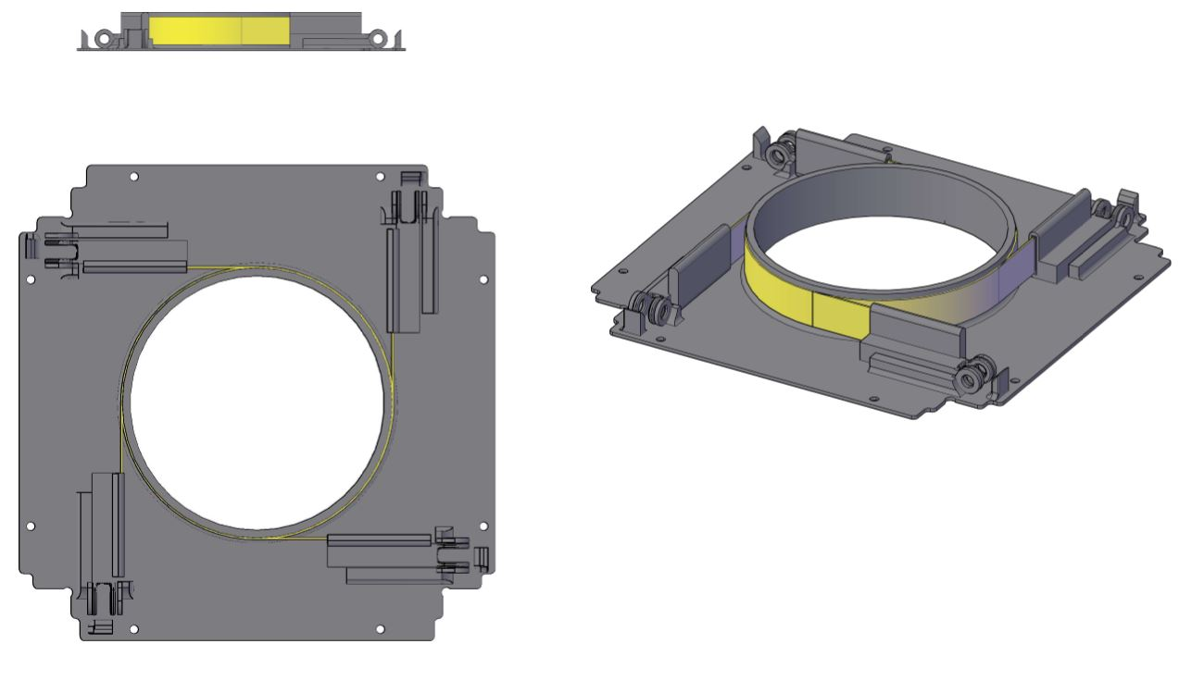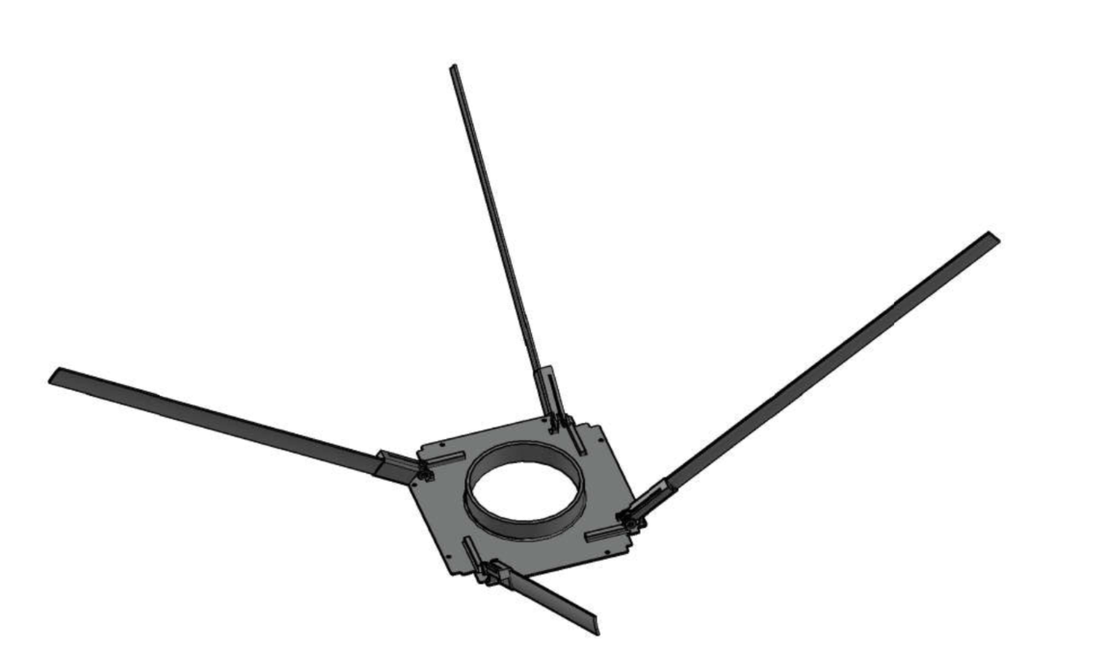

**Figure 1**: The “hinged design”, a modified version of the GOMspace Nanocom ANT430 turnstile array.

The second turnstile design, inspired by the ELFIN cubesat designed by UCLA (Figure A14), achieves the canted turnstile configuration using rolled-up, fiberglass tape springs, epoxy resin, and an embedded beryllium copper strip for the conductive element (Figure 2). Our initial prototype modified this concept by employing tape measure spring steel as both the conductive and structural elements.

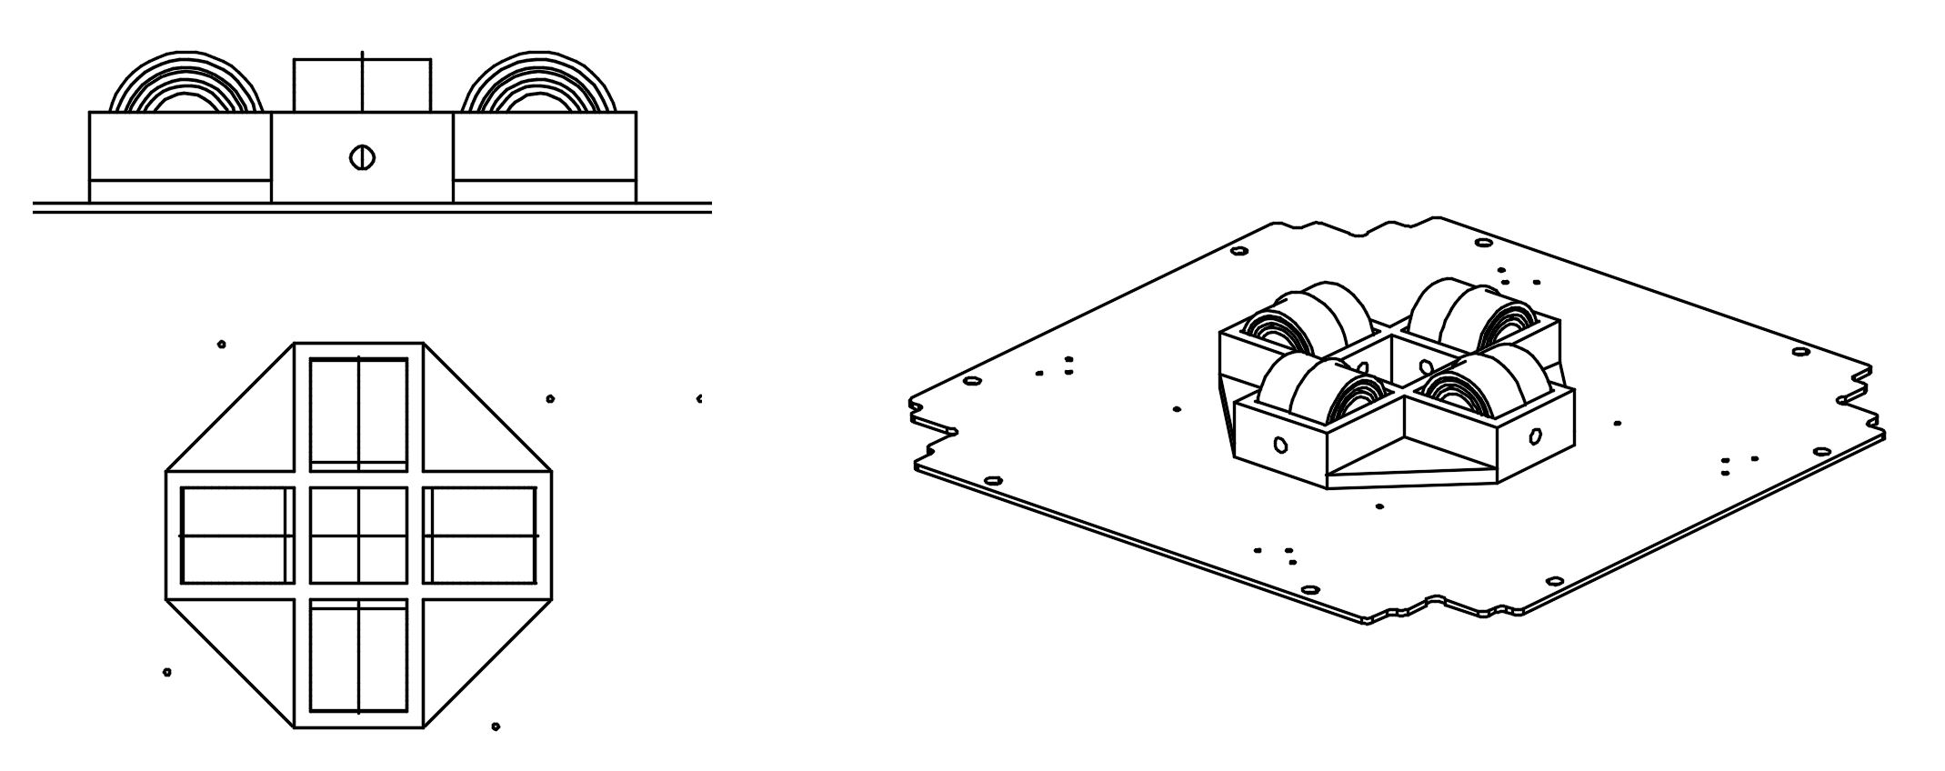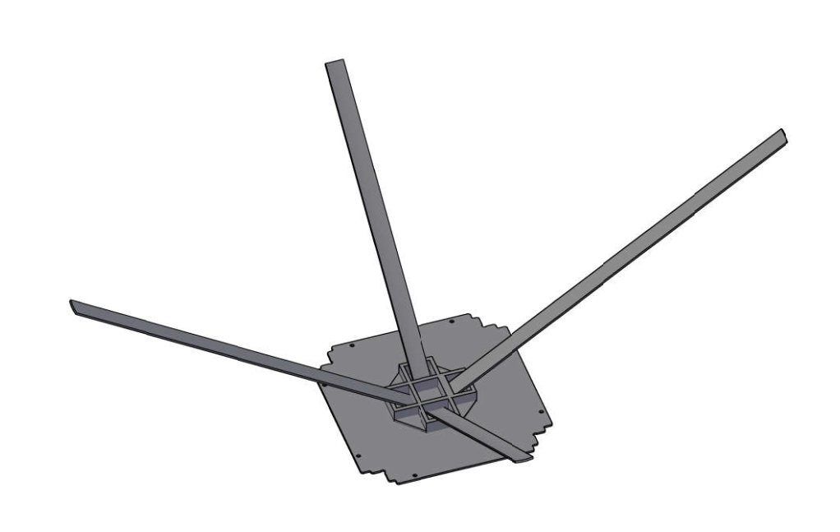

**Figure 2**: The “roll-up design”, a modified version of UCLA’s ELFIN cubesat canted turnstile array.

This design was very desirable due to its simplicity-- there are fewer moving parts-- and the connection to the board remains stationary.

More than halfway through the design process, the requirements of the turnstile changed quite drastically. It was requested that instead of a single conductive element per pole, there be four conductive wires in each of the four poles. In addition, each wire had to be insulated from all others. This meant a non-conductive structural element was required and the hinged design was discarded in favor of the roll-up design. The complicated nature of connecting four wires to the board through a micro-hinge, and the complexity of the deployment mechanism made the GOMspace design undesirable; efforts were then focused on researching, designing, and manufacturing non-conductive, fiberglass tape springs for the roll-up design.

The second antenna is a high gain, S band helical design. This highly directional transmitter will be used to stream video from the satellite cameras to handheld ground stations. The team was tasked with designing a deployment mechanism and integrating it into the satellite’s structure.

The details of the antenna had not been finalized by the project’s sponsors by the start of spring term. The electrical engineers proposed that we design the system around the satellite’s mechanical constraints; the RF properties of the helical antenna are flexible which allowed us to exercise some creative freedoms. However, the design space was severely limited by the spatial constraints imposed on the subsystem. Since OreSat does not have a ‘tuna can’ (Figure 3), the helical antenna must stow as flat as possible.

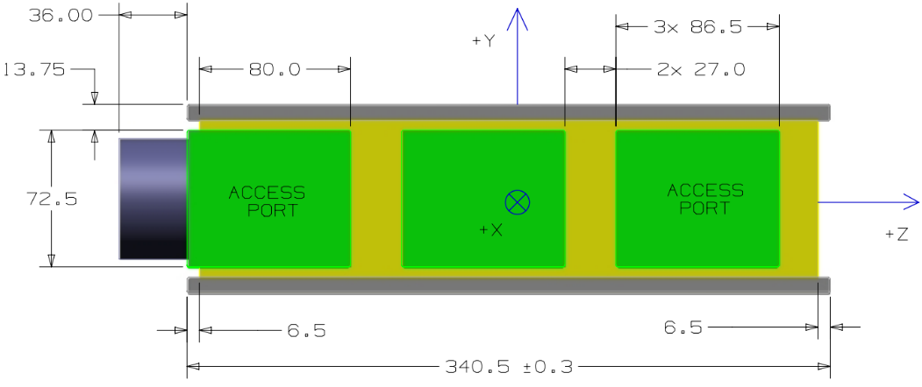

**Figure 3**: Dimensions of a ‘tuna can’ on a 3U CubeSat⏤a bonus usable region commonly used for antenna packages.

The OreSat structure is divided into a series of PCB card slots with 10 mm between each. By mounting the helical antenna on the uppermost card slot, we are granted an allowance of 17 mm beneath which the compressed antenna must neatly stow. At its fully deployed length of 460 mm, the helical antenna triples the length of the 2U satellite. Achieving such an extreme packing factor proved to be quite challenging. We began tossing around ideas of a non-uniform helix. With a sufficiently diminishing radius, such a design would allow the antenna to fully compress to a height nominally greater than its wire thickness whereas a stacked uniform helix’s height is a function of its number of turns.

Determining whether this type of antenna (and others similarly brought up in brainstorming sessions) would meet the customer’s requirements necessitated detailed modeling and simulation. One of the team’s member’s dove head first into this challenge and produced definitive results using analysis packages in MATLAB and Simulink (Figure 4). The results clearly showed that such non-uniform designs would not produce enough gain to transmit high-definition video from space.

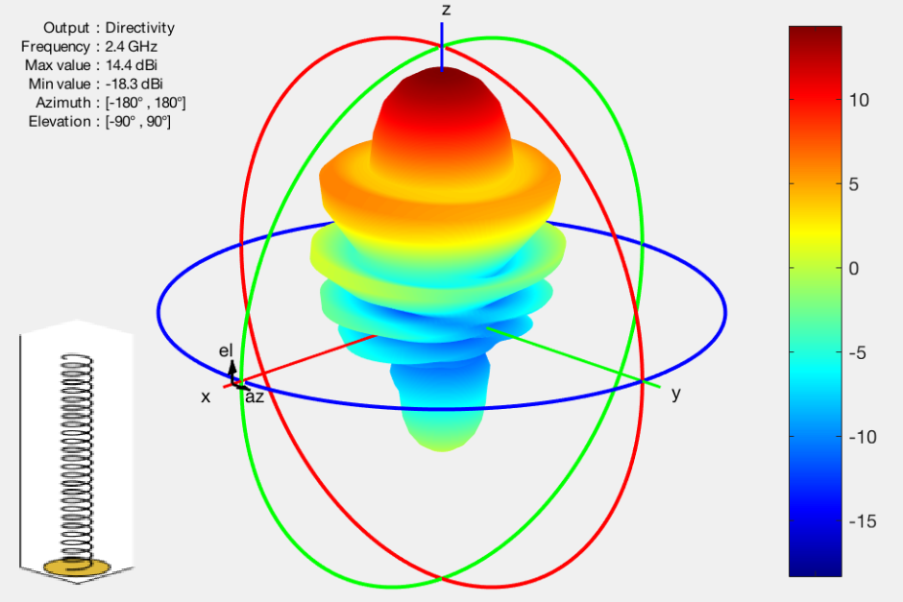

**Figure 4:** Propagation pattern and gain of one of the helical designs being tested.

Limiting the antenna to a uniform helix helped simplify the challenge. Rather than trying anything fancy, we set out to design the most straight-forward and compact system. This led to the use of a relatively fine-gauge wire. Conceptually, the uniform helical antenna is nothing more than a compression spring. With such an extreme spring index, it is incredibly soft and deformable on its own. The OreSat mission requires the antenna to be relatively stiff. An attitude control system (ACS) will periodically change the rotational velocity of the satellite’s structure, putting an inertial bending moment on the antenna. If the antenna is not straight, then it will not transmit the desired signal⏤neither will it point where the ACS directs it.

Competing designs use a series of tethers to constrain their released helical antennas. These tethers run along the length of the helix and attach to each turn. By designing the free length of the spring to be sufficiently longer than its deployed length, the tethers maintain tension as they keep the spring nominally compressed. These static forces make the antenna extraordinarily stiffer than an unconstrained spring.

The tethers precisely define the pitch and overall length of the deployed spring. After being fully compressed for upwards of 6 months, the material is susceptible to stress relaxation. While the loss of deployment force is not enough to be concerned about, the change in free length would have been a major issue for an unconstrained spring. Keeping the spring nominally compressed while fully deployed ensures that the tethers define the pitch and overall length of the spring. Otherwise, we would have to experimentally determine the deployed length of the stress-relaxed spring and then empirically determine the manufactured length required to hit our target.

Finally, tethers provide a damping system for the spring in the event of ACS induced oscillations. Hand-held demonstrations show that, after being subjected to extreme displacements, the tethered system springs back to its intended shape in less than one second. The free spring, on the other hand, slowly attenuates over the course of 10+ seconds before finally damping its oscillations. The tethers help create a remarkably resilient helical antenna system that is fit for deployment.

The design of the deployment mechanism (Figure 5) was influenced by that of a much larger satellite, designed by a team in India, called AISat[1]. Chosen for its simplicity and elegance, the mechanism consists of three hinged arms constraining the compressed helix against three brackets. Each is loaded with a torsion spring and is held in position by a single burn wire which wraps around the circumference of the subsystem. Once the burn wire is released, the three hinges spring open, allowing the compressed helix to deploy using its own stored potential energy.

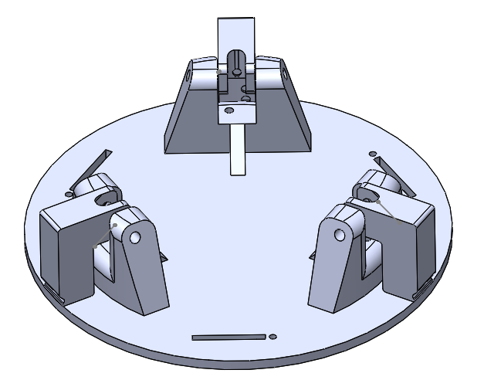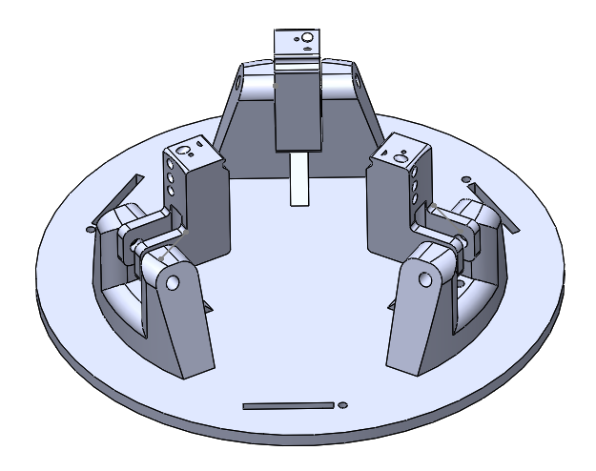

**Figure 5**: Three hinged brackets constrain the helical antenna prior to deployment.

Numerous iterations of the release mechanism were 3D printed and tested to ensure a smooth deployment. The design must minimize the possibility of the helix becoming tangled as it releases. It must be as compact as possible, since any unnecessary bulk eats into the allowed 17 mm ceiling. The mechanism must also be lightweight. Mounted in the center of a PCB, it will contribute to the primary bending mode during the vibrations experience while shipping and launching.

## Subsystem Highlights

### Canted Turnstile Array

The final design of the canted turnstile array closely resembles the ELFIN antenna concept mentioned above-- rolled-up bistable, fiberglass tape springs with burn wire deployment. This design allows us to embed the requested antenna wires between fiberglass layers, providing insulation for the conductive elements, structural rigidity and the ability to deploy using stored strain energy rather than additional actuation.

#### Bistable Spring Manufacturing

In order to meet the non-conductive, mechanical requirements of the system, the structural components of the antenna poles have been designed out of a plain weave, E-glass fiberglass, style 7781, pre-impregnated with epoxy resin. This material is durable, flexible and thin, making it an ideal candidate for manufacturing bistable tape springs. A bistable tape spring rests in either of two stable configurations-- coiled and stowed, or straight and fully deployed-- as seen in Figure 6.

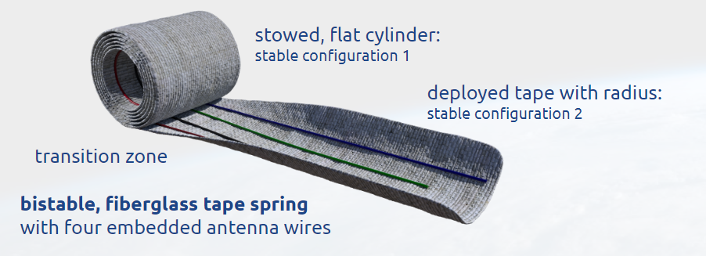

**Figure 6**: Illustration of a bistable, fiberglass tape spring in both its stowed and deployed configuration.

For long-term stowage, the tape springs will be rolled into stable, flat cylinders less than 17mm in diameter to meet the space constraints of the end card. The four cylinders will be held in their coiled position by two separate nylon monofilament lines and two one ohm resistors as seen in Figure 8. When activated, current will pass through the resistors, generating enough heat to melt through the monofilament lines, causing them to fail. At this point, the strain energy in the bistable tape spring will be released and the antenna poles will spring out into their stable, fully deployed configurations.

To enable the springs to adequately store strain energy, the fiberglass requires precise manufacturing techniques. Following the methods detailed in the “Design and Manufacturing of Thin Composite Tape Springs” by Jakob Ekelow, several fiberglass prototypes were created. Manufacturing bistable tape springs requires fiberglass to be cured with a specified radius. This was accomplished using molds created by cutting ½ inch diameter aluminum rods in half longitudinally, fixing them to the top of ½ inch thick wood planks, achieving a rectangular cross-section with one end terminating in a ½ inch diameter semicircle as seen in Figure 7. The plain weave fiberglass was then cut to length and carefully layered on the molds in orientations of -45, 0, 90 and 45 degrees. According to Florian Herlem’s paper, “Modelling and Manufacturing of a Composite Bi-Stable Boom for Small Satellites”, the 45 degree layers provide the stresses necessary for proper spring deployment, while the layers oriented at 0 and 90 degrees add resilience and mitigate the relaxation effects due to long-term stowage. The final design will incorporate the four conductive wires embedded between these layers to give the array four separate channels for communicating with ground.

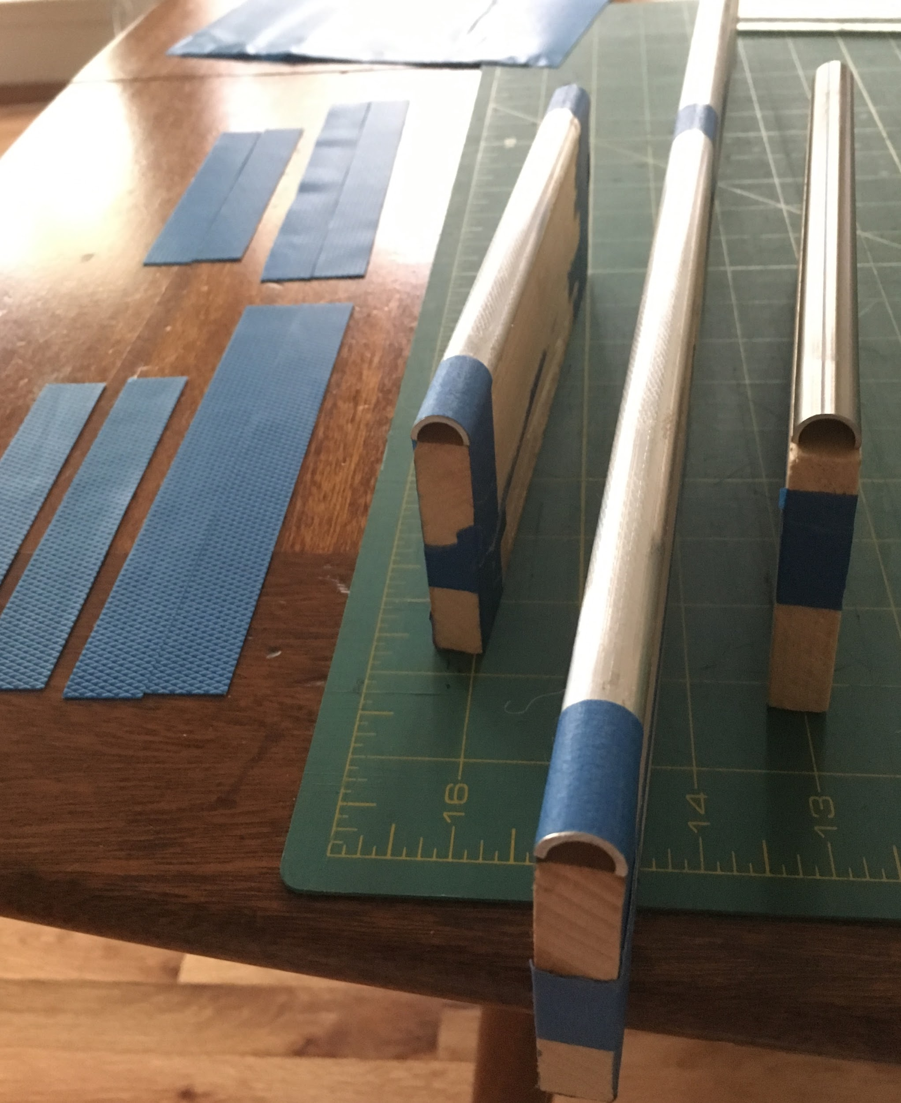

**Figure 7**: Fiberglass molds made from aluminum rods, wood, and tape with a teflon layer to keep the fiberglass from bonding to the aluminum during the curing process. Also pictured, cut pre-impregnated fiberglass strips.

#### Deployment Structure

A deployment structure, to be manufactured from anodized aluminum in the final stages, has been designed to constrain the tape springs during stowage, ensure contact between the burn wires and resistors, and project the deployed tape springs to their proper degree of incline. The deployment structure also firmly mounts the base of the fiberglass components so that the electrical connection point does not move and there is no risk of the connection being broken.

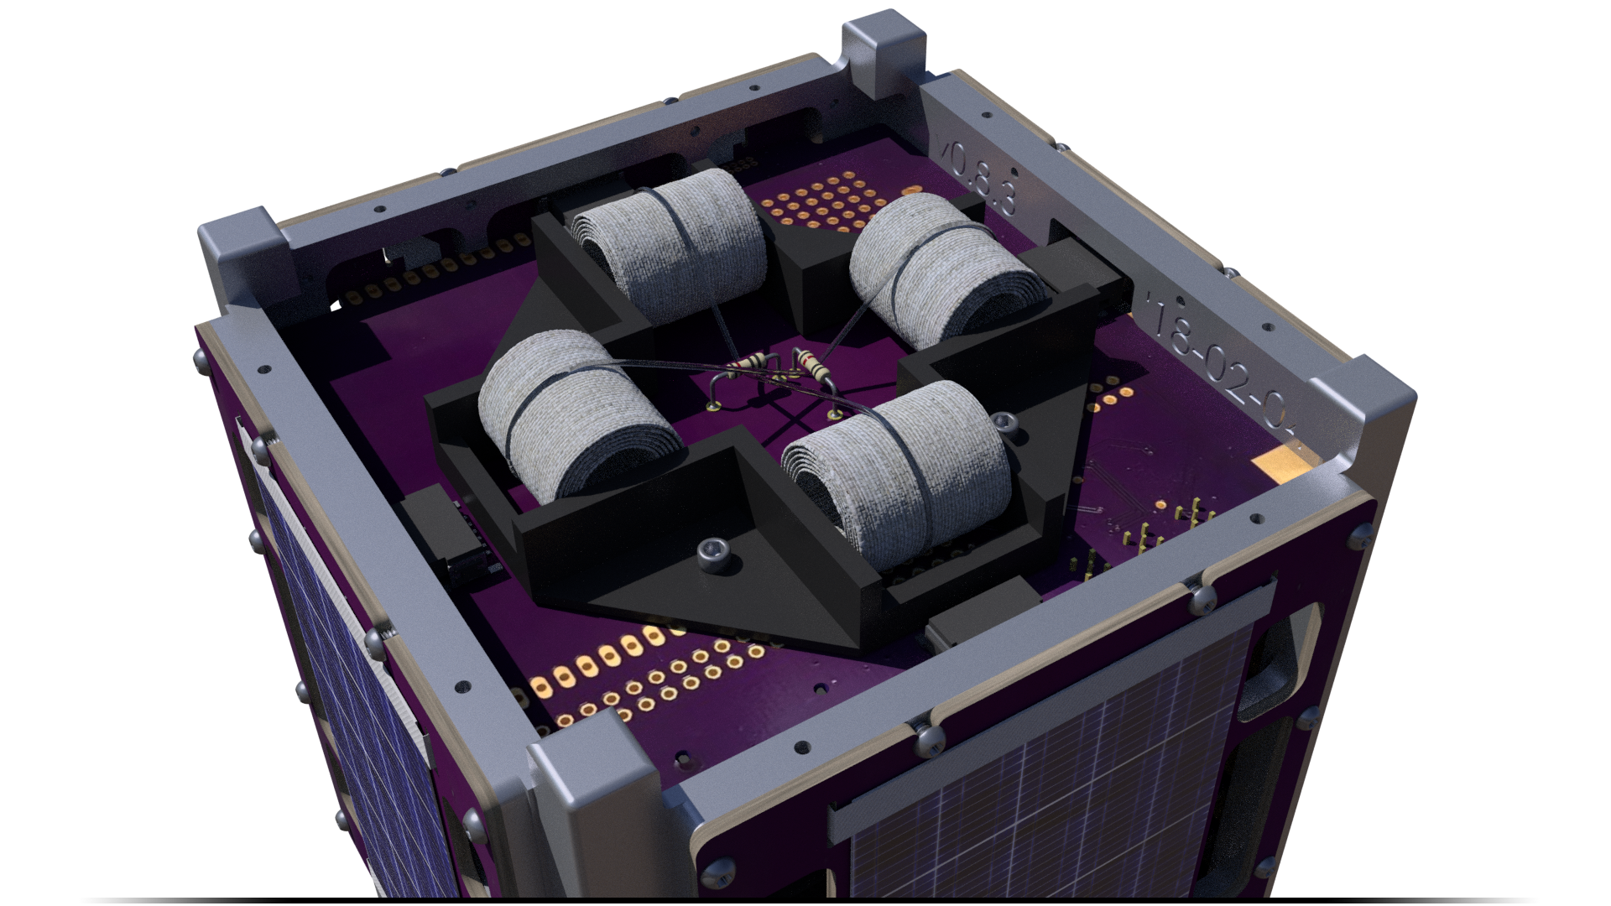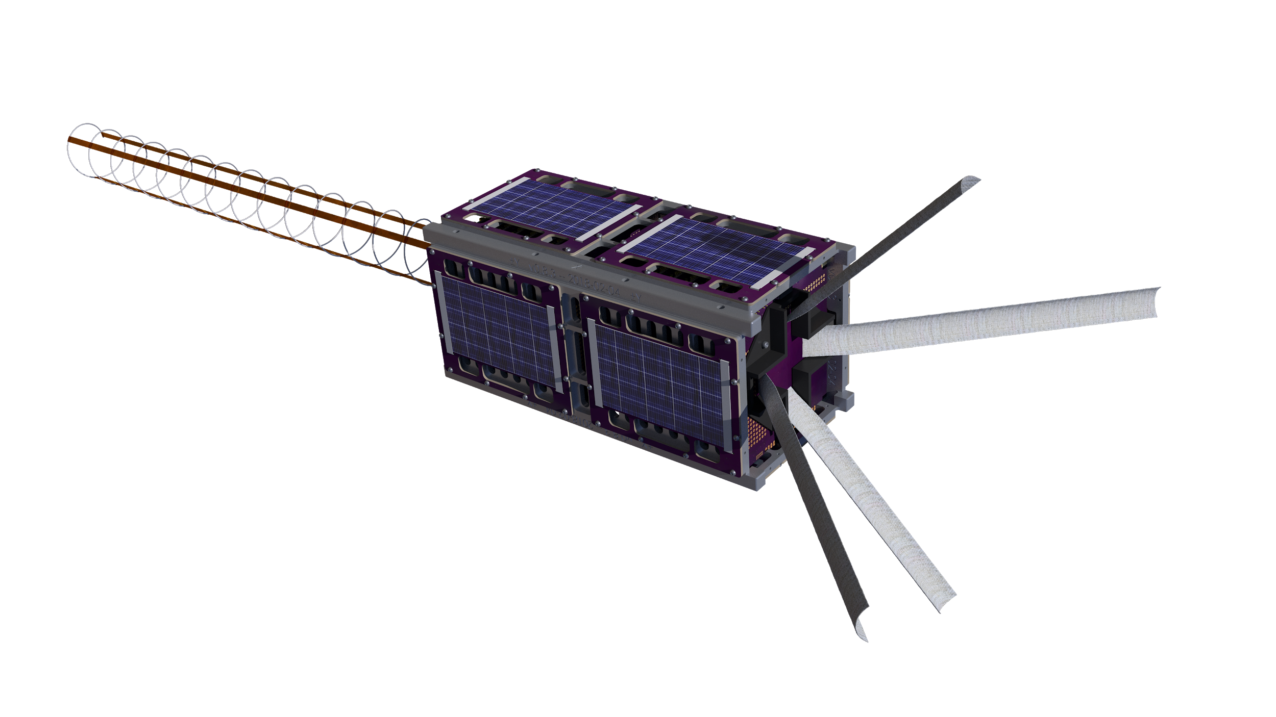

**Figure 8**: The canted turnstile array in both its stowed and deployed configurations.

### S Band Helical Antenna

#### Spring Manufacturing

Substantial effort was put into manufacturing the spring ourselves. Early attempts relied on making smooth mandrels around which the wire was coiled by hand. Without groove to control the pitch, the coils were stacked neatly next to each other. The springback of the material was quite reliable and empirical curves were drawn to help predict the resulting diameter. Pitch was elongated by plastically deforming the spring in tension. Similar attempts relied on wrapping the spring around power screws of approximately the right dimensions (Figure A5). These efforts yielded springs that enabled us to prototype tether and release mechanism designs, though they were nowhere near accurate enough for RF purposes.

The next logical step was to attempt manufacturing with the assistance of a lathe. The chuck was spun by hand since even a slow-turning lathe would create an unsafe situation for such a delicate procedure. The thread-cutting mechanism defined the pitch as the wire is being wound around a smooth mandrel (which was conveniently honed to the correct diameter on the same lathe). The wire was fed through a guide which was mounted on the machine’s tool holder. We fashioned a system to keep constant tension on the wire by hanging weights along the side of the machine. Despite these measures, we could not manage to produce consistent springs on the lathe. It is not clear where we went wrong, but in the end we went back to wrapping the wire by hand until we contracted a local spring manufacturer.

The professional springs were sourced from Dependable Springs in Newberg (Figure 9). The team made a couple of trips out there to tour the facilities and consult the experts. They suggested we use beryllium copper which is one of a handful of common materials used in metal springs. Its mechanical properties are more than sufficient for the helical antenna design and our local supplier conveniently provides it with a silver coating which improves its electrical conductivity and solderability⏤important considerations for successful integration with the OreSat bus.

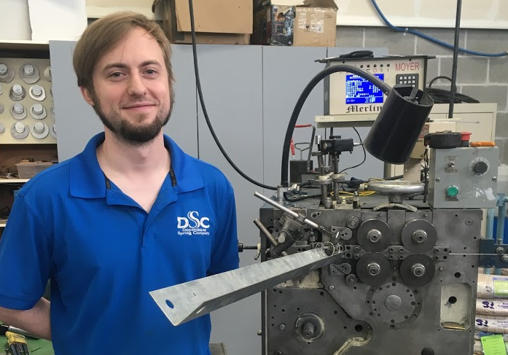

**Figure 9:** A proud Dependable Springs employee standing next to a newly forming spring.

Outsourcing spring manufacturing was an excellent experience. However, a short-sighted mistake led to us ordering a batch of springs with the wrong specifications. We failed to account for the fact that compressing a spring increases its diameter--quite significantly, it turns out. While compressing the spring from its free length to its deployed length, the diameter grew by nearly 6 mm. This mistake did not slow us down. We continued to prototype and iterated on the tether and deployment mechanisms with the abnormally large diameter; the next batch of springs will be properly sized and the mechanisms can be easily modified to match.

Another overlooked fact was that the free end of the helix does not experience the same forces as any other cross-section along its length. Merely pulling down on this bit of the spring is not sufficient to give it the proper shape. The effects of this aberration on the RF characteristics of the antenna have not been determined, but the problem can be easily remedied by adding a small secondary tether connecting the bit of the wire on the other side.

Finally, the fixed end of the spring needs to be closed. The local spring manufacturer did not have a method for achieving this design on their machinery, so we opted to try and close one end by hand. The process should not be too difficult to get approximately right, but we will want to figure out a more accurate solution for the flight article.

#### Constraint Tethers

The commercial market for off-the-shelf CubeSat communications packages is dominated by a Danish company known as GomSpace. They offer a helical antenna which is quite similar in design to ours. It relies on a complex tether system consisting of monofilament stringers running along the length of the antenna and an internal triangular helix of more monofilament line. We had neither the room for or the interest in dealing with tying dozens of little knots in order to constrain our helix. Without the luxurious space afforded by a tuna can, we must worry about the thickness of the material used as tethers. Because they are attached at each turn of the helix (necessary to avoid buckling), the thickness of the tether gets multiplied by the number of turns and the product is added to the stacked height of the antenna. Using knots or drops of adhesive only further adds to the stacked height which can quickly become untenable.

Rather than monofilament, we decided to use thin strands of ribbon (Figure A3). This proved to be a much simpler approach as it did not require tying any knots. However, it suffered from one difficulty: friction was not sufficient to keep the ribbon from slipping radially around the helix. The spring force attempting to separate the turns of the spring was enough to cause the ribbons to slip out of position, causing the antenna to buckle. Using adhesives to keep the ribbons in place was proving problematic (stiffening of the fabric and adding to the stacked height), so we continued brainstorming.

It was ultimately conceived that two strips of Kapton tape should pass over the wire and bond to each other (Figure 10). This configuration was exquisitely simple in both its design and assembly. Two layers of the Kapton tape available in the laboratory summed to a mere 0.1 mm per turn, contributing a grand total of just 1.6 mm over the entire helix. This is quite significant compared to the ~0.5 mm per turn characteristic of both the fishing line and various ribbons used in early designs (Figure A2).

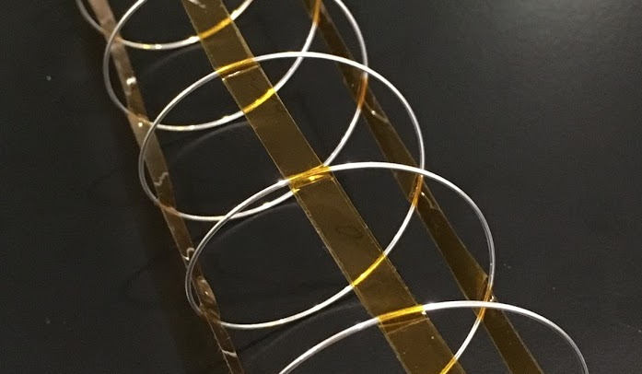

**Figure 10:** Kapton tethers used to constrain the deployed helical antenna.

The design proved itself to be viable. The spring holds its shape very well and quickly damps out any vibrations. However, Kapton tape is not viable for use in low Earth orbit. The adhesive used to bond the strips together will degrade, allowing the partially-compressed antenna to lose its desired shape over time. Future work is needed to identify better methods for bonding strips of polyimide. This should not change the design of the system - only the method of manufacturing and assembly.

#### Deployment Mechanism

The deployment mechanism (Figure 11) went through a series of subtle changes as we tested the prototypes made on a 3D printer. The latest design functions properly and meets the design constraints. There are a number of issues which remain to be addressed. We focused on developing the mechanism for rapid prototyping so that we could test the fit with the various handmade and professional springs, the different tether systems, the burn wire, and mockups of the satellite structure. Future work is needed to settle on (non-conductive) flight materials and to focus on design for manufacturing. Conceptually, the bits are in place; we simply need to adapt the design to be flight-ready.

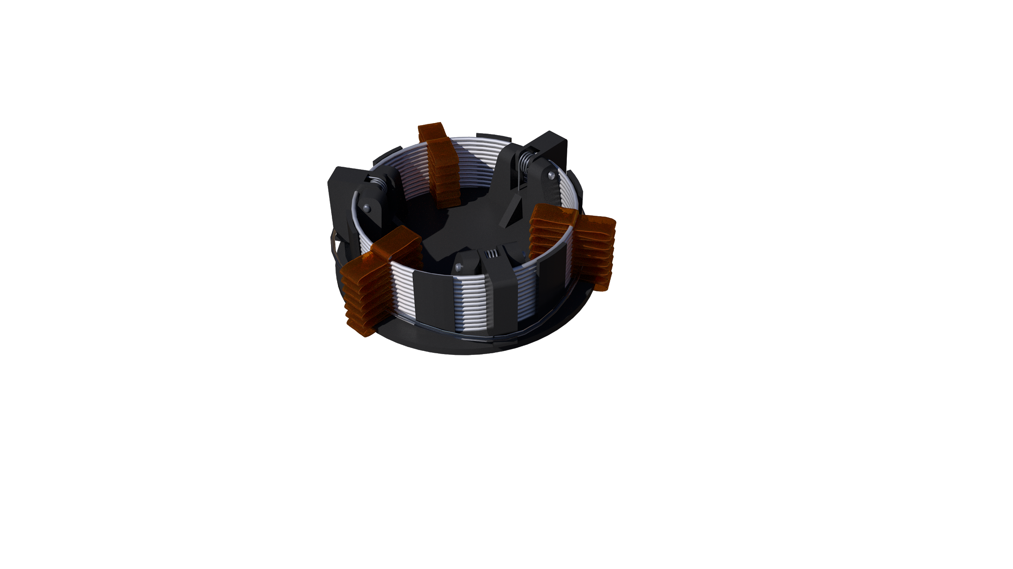

**Figure 11:** Rendering of the stowed helical antenna system.

### Burn Wire

The burn wires are nylon monofilament fishing line wrapped tightly to constrain the antenna systems until they are ready to be deployed (Figure 12). For the turnstile array, the monofilament is run over the top of each antenna pole after they have been tightly wrapped into the stowed, cylindrical, configuration as seen below. The burn wires then meet in the center of the deployment structure where they are held down by two 1 ohm resistors. The tension created by the stresses in the rolled antenna poles ensure that the nylon monofilament is kept in contact with these resistors so that heat can be transferred efficiently.

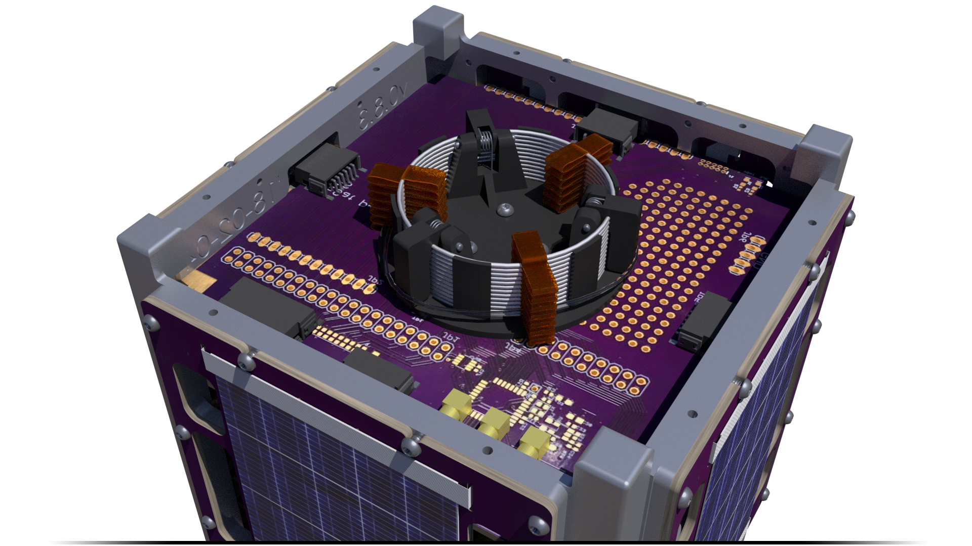

**Figure 12**: Both antenna systems are constrained by burnwires.

In the helical antenna system, the nylon burn wire is wrapped around the three constraint hinges that prevent the antenna from deploying. A resistor is also placed across the burn wire and the tension to ensure contact between the two is provided by the torsion springs that are embedded into the constraint hinges. The resistor is activated, melting the nylon burn wire, and deploying the antenna in a similar fashion to the turnstile array.

Several thicknesses of nylon monofilament line and different values of low-resistance resistors have been tested and proven to be viable in a low pressure environment using a full factorial experiment detailed in a burn wire test report[2]. However, additional simulations and vibration tests are required to validate the robustness of the system under launch conditions.

In theory, the burn wire systems are fail-safe; should they fail to deploy (due to faulty electronics, bad resistors, etc.), prolonged exposure to ultraviolet radiation in low Earth orbit will eventually degrade the nylon and cause the systems to deploy. Future work is needed to validate this theory and determine the time scales required by this fail-safe mechanism.

## Performance Summary

The nature of the project and its client’s requirements meant that our team did not produce a lot of tangible data with which we can tout the successes (or failures) of the individual subsystems. Most metrics for the project’s success are qualitative and binary; they either work or they do not. Early into the spring term, we decided that RF testing of the antennas was beyond the scope of this capstone. Whatever the deployment design, it does not significantly affect the electrical properties of either system, so we would have done the client a disservice by distracting ourselves with experiments that are irrelevant to the mechanical design.

That said, the burn wire mechanism was the most extensively tested (as documented in the aforementioned report), ensuring reliability in a vacuum environment. While maintaining tension in the monofilament was relatively inconsistent, it still managed to transfer enough heat during the vast majority of the tests. Further testing will determine how quickly the burn wire will degrade as a fail-safe mechanism in a high-radiation environment.

The design for the turnstile array has proven to be imminently successful. The simple mechanism does not provide many opportunities for failure, and it has been demonstrated to work repeatedly in ambient conditions. Successful deployment is contingent only on the integrity of the material and the functioning of the burn wire mechanism. While the functionality has been shown using metallic members, the switch to fiberglass came too late in the year to allow for adequate development. The design is conceptually sound and has been demonstrated by other teams. It will simply take more time before we can demonstrate its success directly.

The helical antenna has qualitatively demonstrated its resilience to rotational acceleration and resulting oscillations; the tethers system has proven itself worthy. The deployment mechanism has not been sufficiently tested nor has its function yet been exhibited to the client. This is a shortcoming of the project that will be rectified over the summer as a portion of the team continues to work with OreSat.

None of the subsystems were tested as extensively as was originally planned. Resources for vibration testing were secured, but we did not find the time before the end of the spring term to begin the process. Other environmental testing is needed to guarantee the success of any of the systems, and we are continuing to work on facilitating those tests. A proper vacuum chamber was recently acquired and we are pursuing leads for Highly Accelerated Life Testing (HALT). These time-intensive efforts will likely continue well into the following calendar year before any system can be definitively labeled as ready to fly.

## Final Status

The finalization of the s-band helix design has been complete. Material selection, wire thickness, coil diameter, length and the electrical connection were all finalized through calculation and approval of the client. As for the helix release mechanism, a few more iterations must be made to account for small geometric changes and to incorporate more compact torsion springs and a correctly sized pin. The final iteration will likely be machined of aluminum and deployment will be tested in free fall.

The recent changes in requirements for the canted turnstile array meant the team was unable to deliver a fully functional prototype using flight-ready materials. The bistable fiberglass tape springs required extensive research in order to determine feasible materials and sourcing was a major challenge. Preparation and manufacturing of the e-glass material has also proven quite time-consuming, though a manufacturing process has been developed and a clear path forward has been defined based on extensive research and documentation of successful implementation in similar designs. Further e-glass materials have been ordered for testing and experimentation over the summer. Materials used by other satellite groups have also been documented but availability is very low or require large order quantities. The overall deployment mechanism of this revised turnstile array has been validated and demonstrated using (the originally viable) metallic structural members as a physical model.

In addition to further work on final antenna design and tape spring manufacturing, the turnstile team has also begun regular communication with the OreSat electrical engineering antenna team which is responsible for modelling the radio frequency response of the design and integrating the conductive wires into the pcb with additional antenna hardware.

The burn wire system has been tested and results have been documented elsewhere. The system has proven to be a dependable method for deploying both antenna systems. Exact materials have not been selected but a variety of nylon monofilament wire thicknesses have been tested and determined to be viable. Future work is planned to test the effects of ultraviolet radiation on the degradation of the nylon as a failsafe mechanism incase the resistive element fails to sever the nylon monofilament once in orbit. Further analysis and testing is also required to ensure vibrations experienced during launch and deployment will not cause the burn wire system to prematurely fail.

The tethers used to constrain the deployed helical antenna needed to be compact and lightweight while minimizing the risk of entanglement during deployment. Strips of Kapton were chosen for the final design for their superior compliance, environmental resilience, and their minimal contribution to the stacked height of the spring. The system proved to be both stiff and quickly damping, mitigating any risk of untenable dynamics caused by the satellite’s reaction control system. The helical deployment mechanism was designed to accommodate the tethers and constrain the compressed antenna while stowed beneath a 15 mm ceiling. It was derived from a mechanism used on an Indian satellite described in an academic paper. Further work is needed to test and validate the design architecture with an eye for minimizing the risk of deployment failure modes.

As is always the case, there remains plenty of work to be completed before any of us are fully satisfied. The following list briefly enumerates the remaining issues to be addressed and work to be done on each of the three subsystems:

* Helical Antenna
  + Constraint of the free end of the helix
  + Closing the fixed end of the helix
  + Mechanical and electrical integration of the helix and the PCB
  + Method for permanently bonding polyimide strips
  + Compensation for twisting of the helix as it compresses
  + Material selection for the deployment mechanism
  + Design for manufacturing for the deployment mechanism
  + Incorporation of the burn wire design
* Turnstile Array
  + Electrical integration of the terminals to the PCB
  + Embed the conductive elements in the fiberglass
  + Manufacture reliable bistable fiberglass tape springs
  + Refine deployment structure’s design
  + Incorporate burn wire design
  + Test, test, test a completed, flight-ready prototype!
* Burn wire UV radiation and degradation testing
* Vibration Testing
* Drop Tower Testing

# Appendices

## Supplemental Images



**Figure A1:** The deployable antenna capstone team. Left-to-right: Paijanne, Justin, Shivani, John, Calvin.

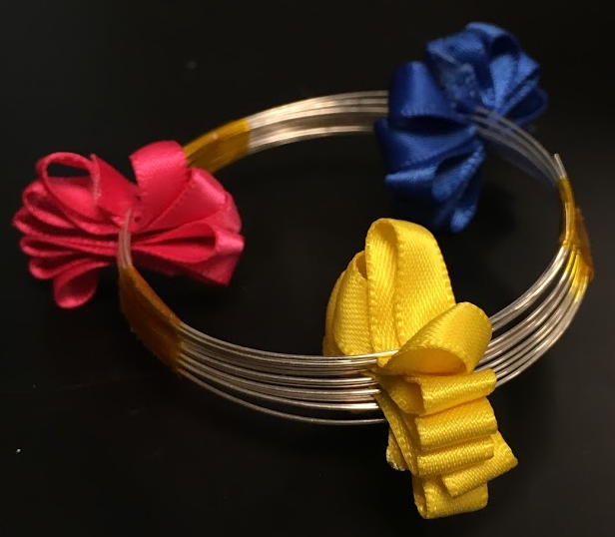

**Figure A2:** An early prototype of the helical antenna’s tether system which used ribbon from an arts-and-crafts store. Notice the thickness of the ribbon interfering with the stacking of the spring.

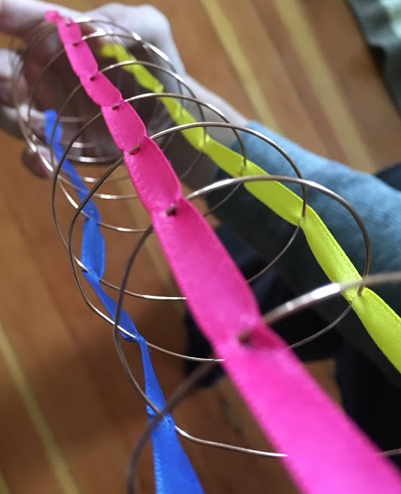

**Figure A3**: The ribbon tethers were pierced by the helix - a method that kept them in place axially but not radially.

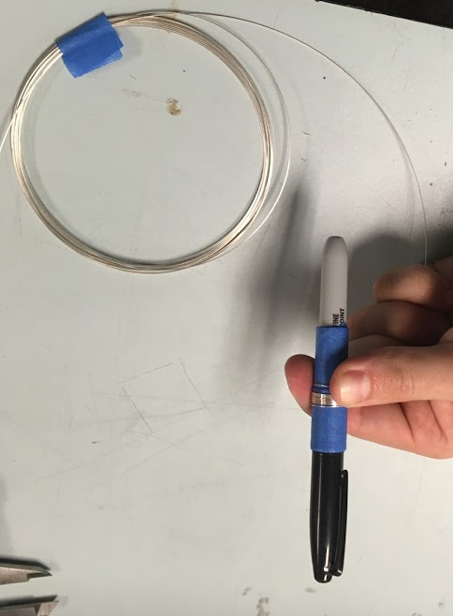

**Figure A4:** We used creativity when making mandrels for hand-wound springs.

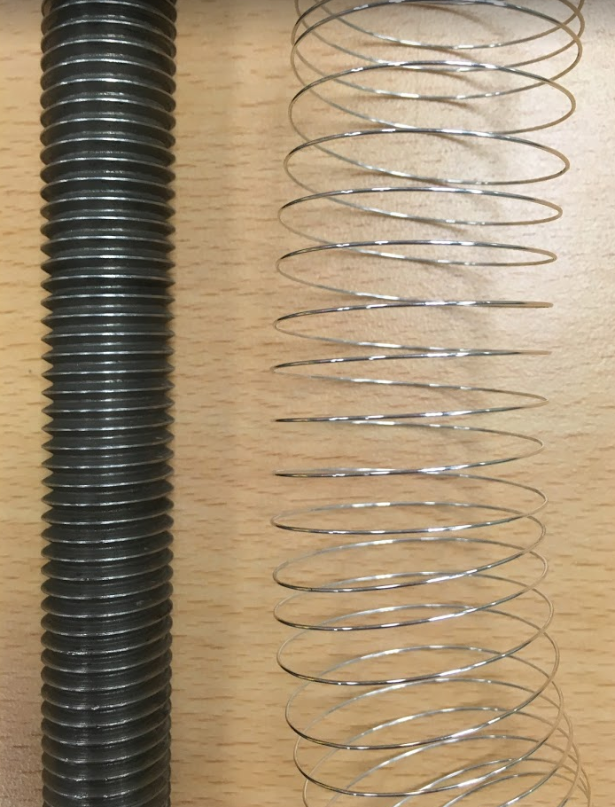

**Figure A5:** Hand-wound helical antenna next to a large screw used as a mandrel. After winding, the spring would be stretched to increase its pitch.

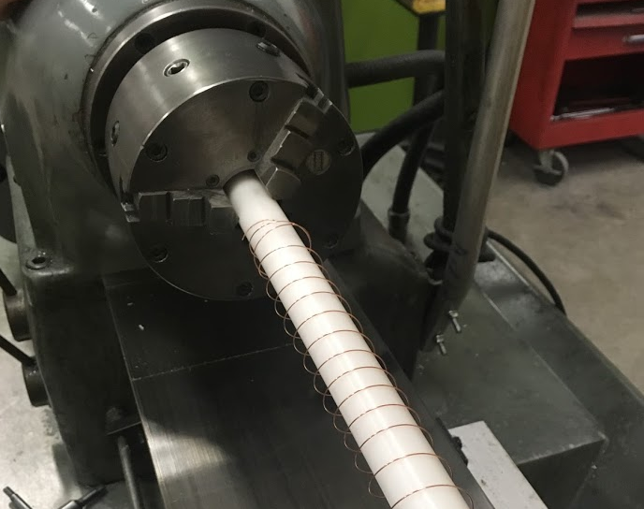

**Figure A6:** Attempts to make the spring on a lathe were largely unsuccessful.

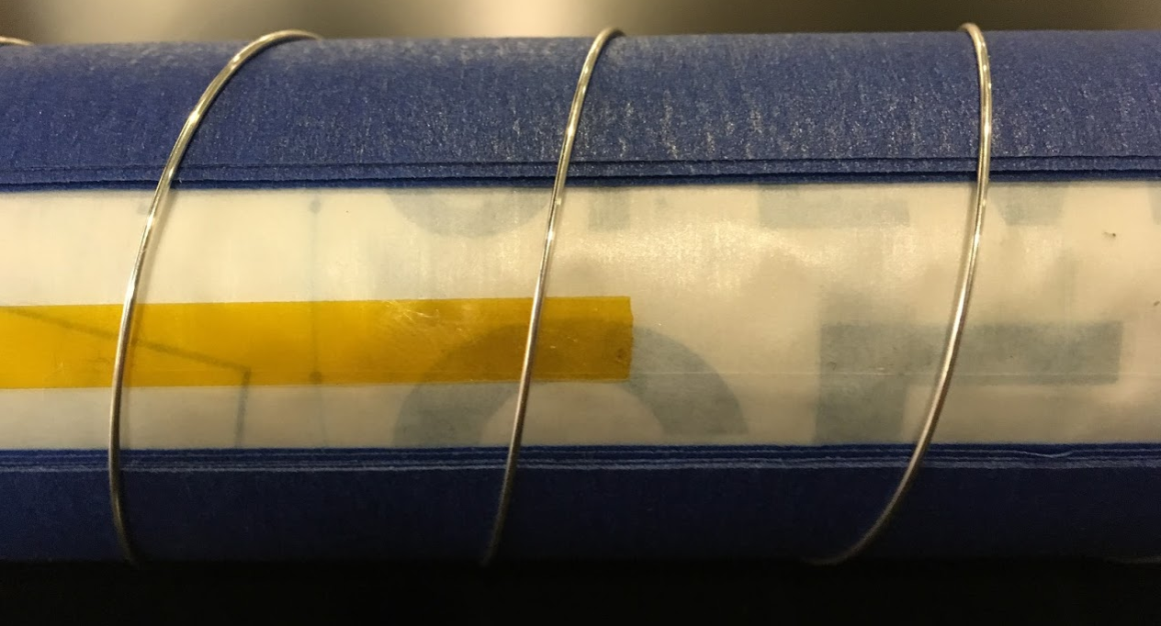

**Figure A7:** The helical antenna on its assembly mandrel. Kapton tape slides through grooves made with layers of painters tape before folding over and bonding to itself.

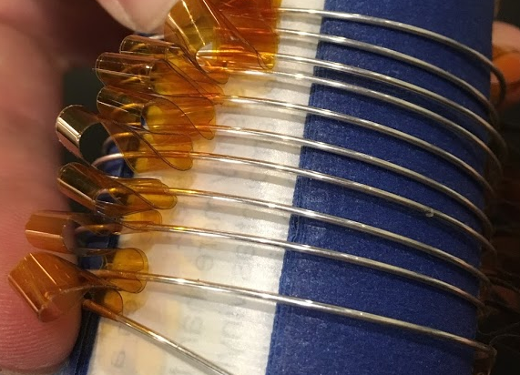

**Figure A8**: Pleats of Kapton tethers on a partially compressed spring.

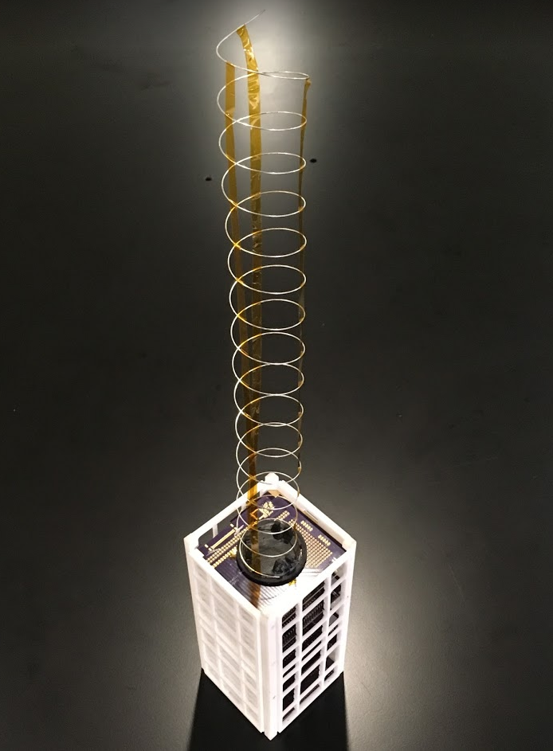

**Figure A9**: The helical antenna attached to a 3D printed prototype of the OreSat structure.

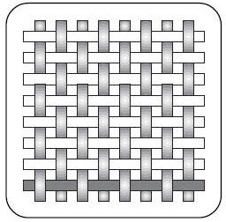 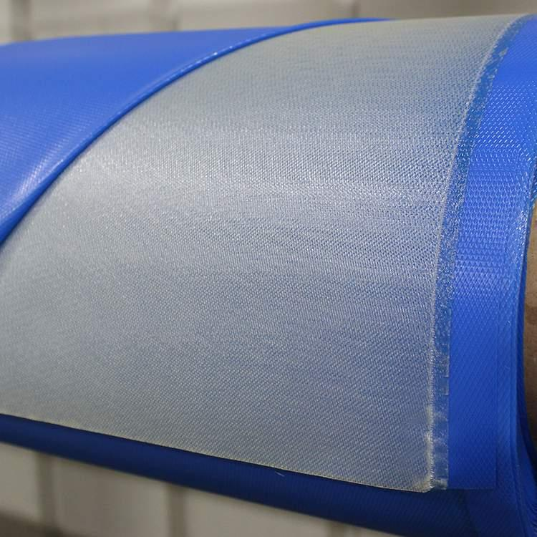

**Figure A10:** Plain weave carbon fiber e-glass orientation and uncured prepreg material.

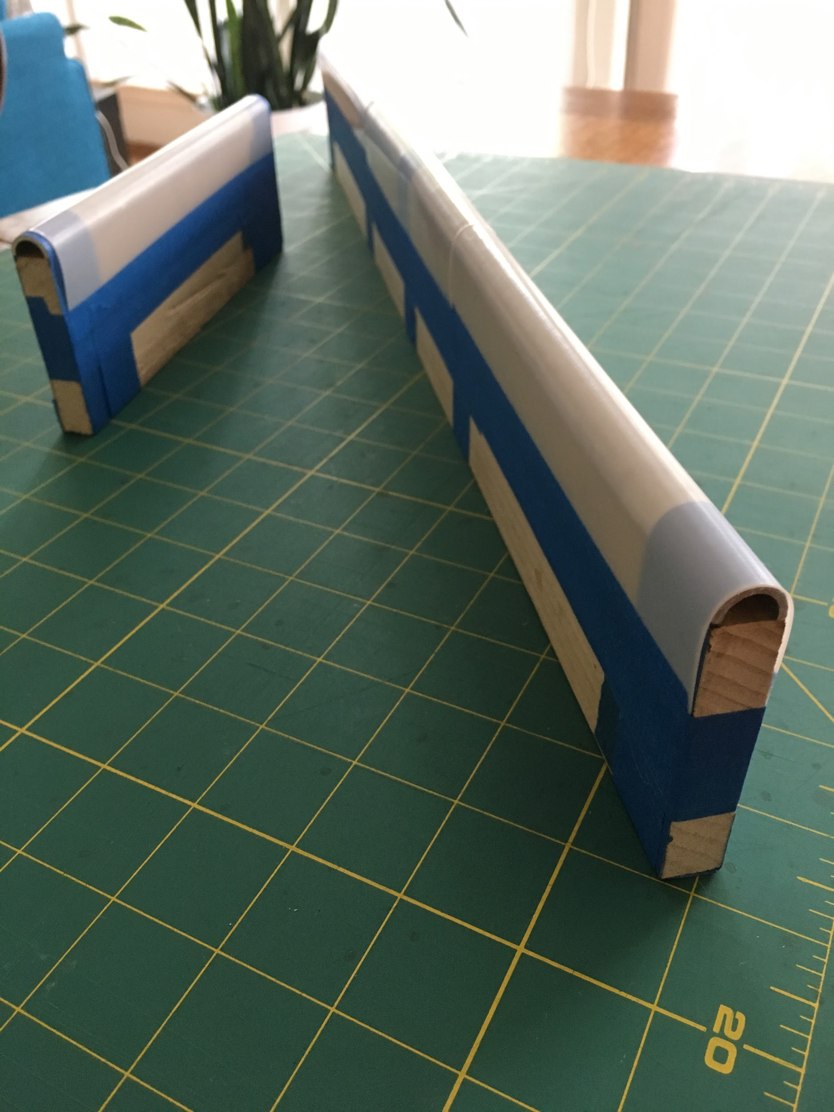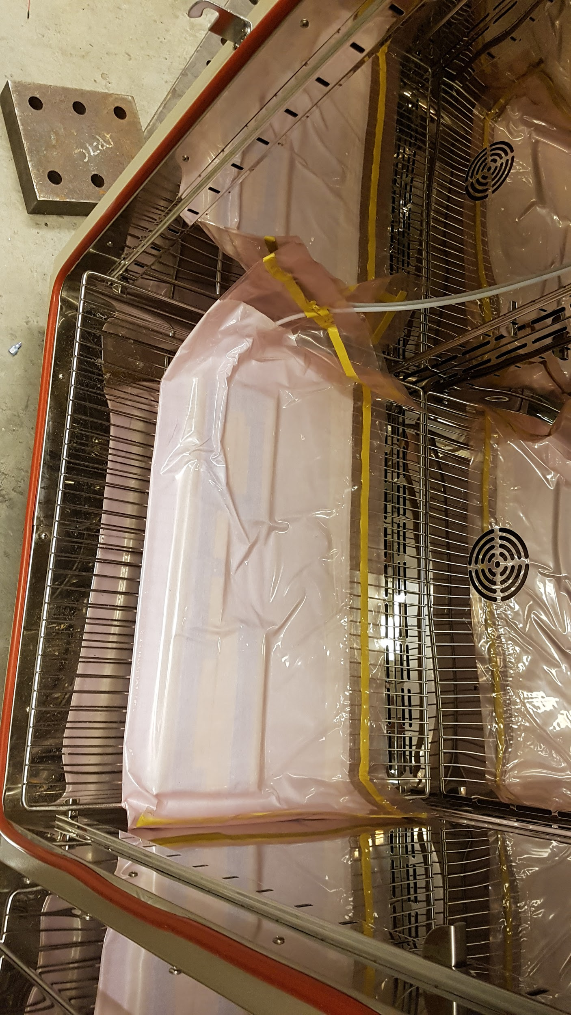

**Figure A11:** Manufacturing process for creating carbon fiber tape springs. Prepared molds(left) and vacuum bagged fiberglass after being applied to mold(right)

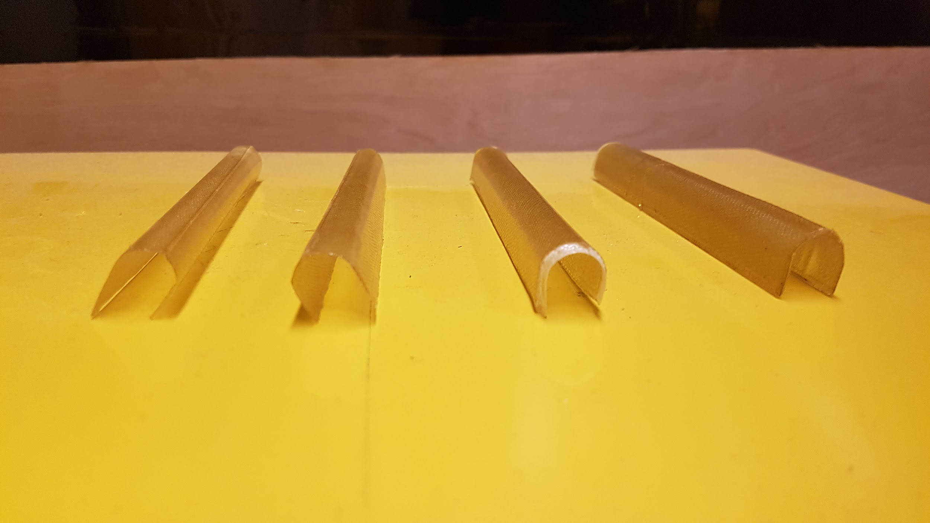

**Figure A12:** Resulting tape forms after layering test. Material properties after layering were tested between 1 and 4 layers, increasing from left to right.

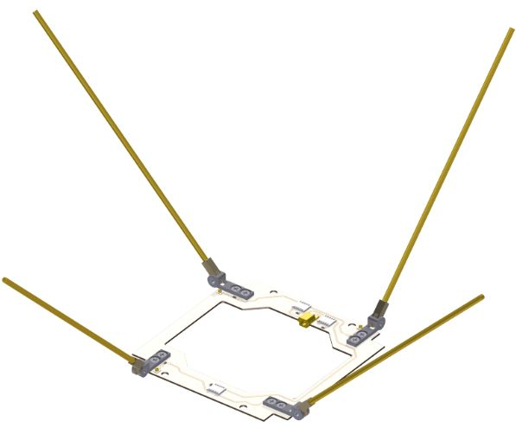

**Figure A13:** GOMSpace Nanocom ANT 430 which served as inspiration for initial hinged design

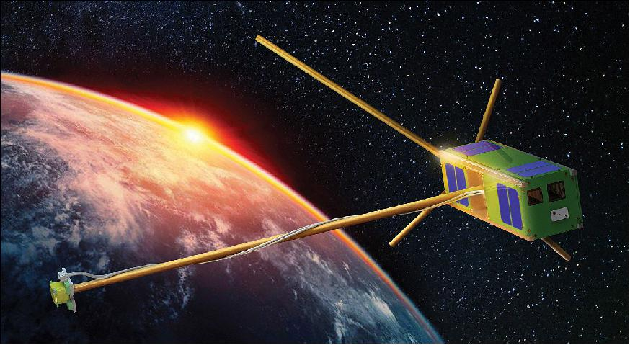

**Figure A14:** ELFIN composite tape spring antenna which served as inspiration for final turnstile antenna array design.

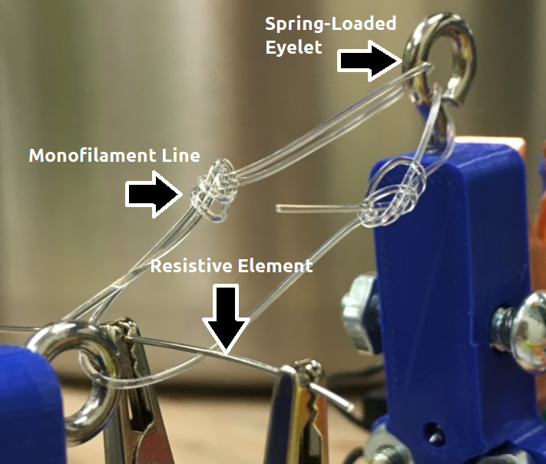

**Figure A15**: Burn Wire testing mechanism: Alligator clips hold a resistive element against a monofilament line. The spring-loaded eyelet on the right is used to send a signal to a microcontroller upon completion of the experiment.

## Catalog of Design Artifacts

All of the design artifacts used and generated by this capstone are stored on a public Google Drive[3] folder and a GitHub[4] repository managed by the OreSat team. Among the artifacts are

* CAD files
* Jupyter notebooks
* Hand calculations
* Experimental data
* Meeting notes
* External literature

Any missing documents can be found by contacting the continuing members of the OreSat team.

## Concept Analysis

Detailed analysis of each of the design concepts has been included in the relevant portions of the main document.

## Bill of Materials

Due to the ongoing nature of the project, a link[5] to a dynamic bill of materials is presented rather than a static list which is liable to become outdated.

## System-Level Requirements Matrix

**Table A1**: Performance metrics[6] for each primary requirement.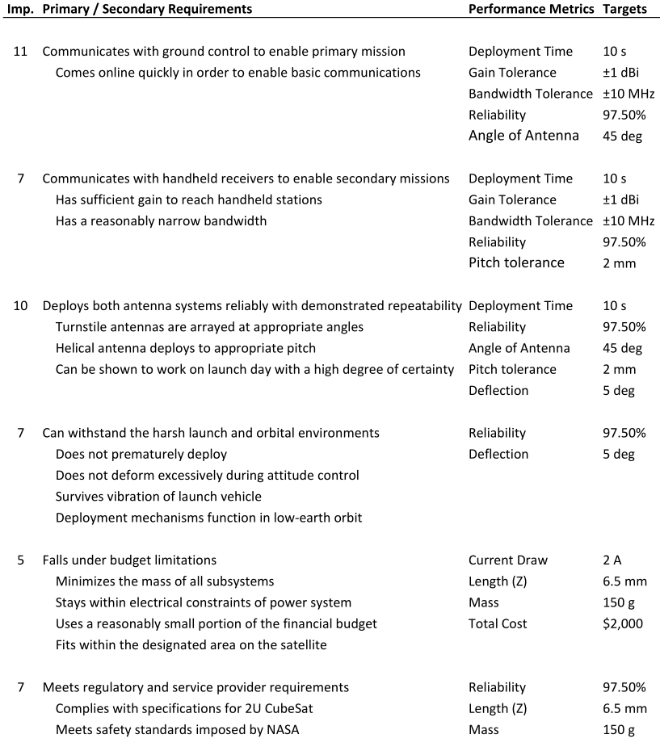

**Table A2**: Requirements matrix linking client requirements to performance metrics.

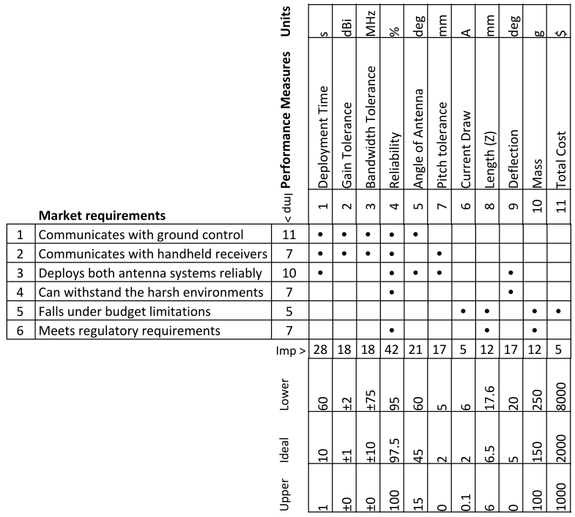

1. http://spaceflight101.com/spacecraft/aisat/
2. https://github.com/oresat/oresat-structure/blob/master/Capstone/Burnwire/Lab_Report.pdf
3. https://drive.google.com/drive/folders/0BzW5XSZ87m-TMUE3TmlhVVI4XzQ?usp=sharing
4. https://github.com/oresat/oresat-structure/tree/master/Capstone
5. https://docs.google.com/spreadsheets/d/1AXiIjH4MGnK2cfRoHppHuekCKAYCAwXwEiLfm1C12NY
6. Many values for the performance metrics are estimates derived from ongoing research and are subject to change and review.